User Documentation

By Tiana Dubovic and Stefan Schneider

Menu:  
The menu is the first screen the users see. It provides various options for the players, the game mode and the game board.

First, the two players have to put in their names and choose a shape and color for their coins. A name may only contain letters, hyphens (-) and blanks and a capital letter must be at the beginning of each word. Every player has her/his own text field to enter the name and two select menus, one for the shape and one for the color of his coins.

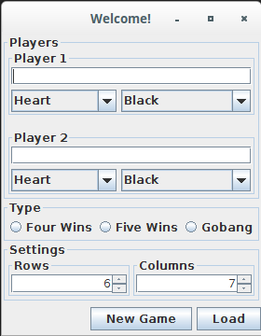

NOTE: Both players CANNOT choose the same color.

After that is done, the game type must be selected. The options provided are “*Four Wins*”, “*Five Wins*” and “*Gobang*”.

When selecting *Five Wins* or *Gobang*, the board must have as many rows as columns.

After all, entering a false input is not critical, for a dialog window will tell you what went wrong.

If you want to continue a saved game (you will see below how to save a game), just the game type must be specified. A click on “*Load*” will open a new window, where the suitable file must be selected.

The Picture below shows a valid input:

In this example, the players are called Alice and Bob. Alice plays with red heart shaped coins and Bob take the black stars. The game is Gobang and they play on a squared board with 7 columns and rows.

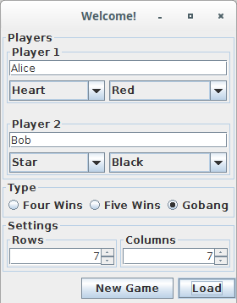

Gobang:

Very much like Five Wins, the game Gobang is played on a squared horizontal board with comparable rules, even the buttons and status labels are equivalent to Five Wins. So two players compete against each other and the player with 5 coins in a row (horizontal, vertical or diagonal) wins. But in Gobang, a player can throw the coins of an opponent, if the following conditions are met:

* Only 2 coins can be thrown
* The 2 enemy coins must be surrounded by your own coins
* The enemy’s 2 coins must already be placed, when you place your last  
  surrounding coin.
* The 4 coins must be in a line (horizontal, vertical or diagonal)

When all these conditions are met, the enemy coins are taken from the board and the 2 coins are added to the enemy’s coin pool.